Supply Chain Analysis
- Overview – This project focuses on analysing supply chain operations like order delivery status, sales performance and delivery risks using Power BI and SQL.
- Tools used
- Power BI
- DAX
- SQL
- Data visualisation
- Business Objectives
- Last delivery percentage
- Analysing delivery delays
- Monthly sales pattern
- Sales performance as per region and category
- Delivery performance improvement suggestion
- Dataset description
- Dataset Name – DataCo Smart Supply Chain dataset
- Source – Kaggle
- Dataset Link - https://www.kaggle.com/datasets/shashwatwork/dataco-smart-supply-chain-for-big-data-analysis?
- Data cleaning and preparation –
- Checking for missing values
- Checked for Duplicates
- Reviewed Date and numerical columns
- Created relationships between tables for easy and precise analysis
- KPI measures –
- Total orders – Calculates total unique orders
- Late orders – Count of orders delivered late
- Late delivery percentage - Percentage of late orders
- Total sales – Measure of total sales
- Average shipping days – Measures average shipping time

- Dashboard

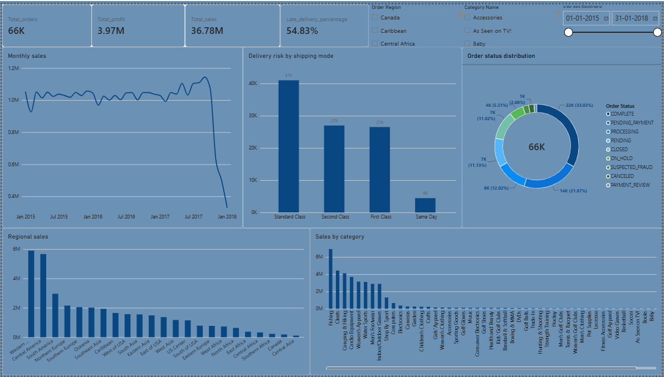

- Key Insights -

- Total number of orders were 66K
- Percentage of order delivered late was 54.83 %
- Total sales were 36.78 M
- Total profit was found to be 3.97 M
- Standard class shipping mode had highest delivery risk
- Monthly sales were lowest during January 2018
- Western Europe generated the highest sales regionally
- Fishing produced the highest sales by category

- Business recommendations

- Review standard class and first class shipping mode for late delivery and improve late delivery percentage.
- Improve delivery planning and scheduling to ensure on time delivery.
- Track delivery regularly to avoid late delivery.
- Track order payments regularly and ensure on-time payment completion.

- Conclusion – In this project we analysed supply chain operations using Power BI and SQL and checked for various aspects like total order, order delivery percentage, sales regionally and categorically for useful insights like sales trends. It helped us know the improvements that can be made like tracking shipments, regular KPI analysis and tracking order payment status.

